Korea YWCA leading the ‘YWCA After You’ campaign in the midst of COVID-19 mask shortage
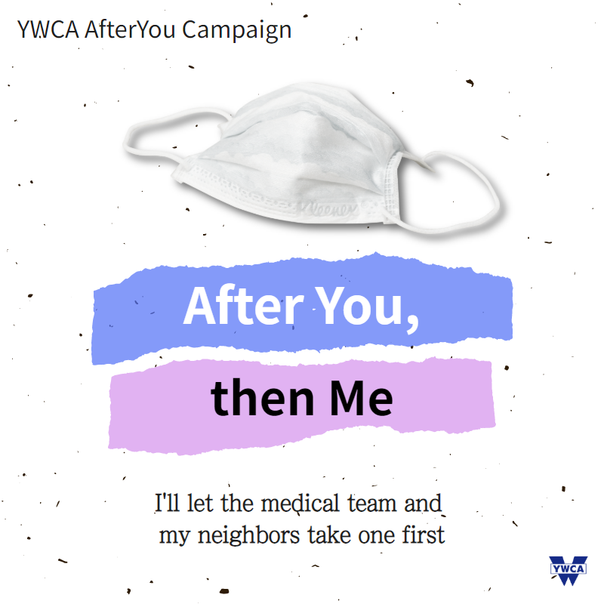

- #I_will_share_mine_first, #AfterYou_thenMe, Caring others first in mask purchasing
- Letting the Medical professionals and Careworkers take the mask first
- Overcoming the COVID 19 outbreak with consideration and tenderness towards others

The National YWCA of Korea(Korea YWCA) with its 53 local YWCA branches nationwide
encourages communities to ‘halt, take a break’ from the daily routines as the numbers of COVID-19 (a.k.a coronavirus) cases constantly skyrockets nationwide.

Starting March 6^{th,} Friday, Korea YWCA launched the ‘YWCA After You Campaign’ which is an expression of consideration and tenderness towards those in need and the blind-spots of the community. It is an online campaign to show the awareness that all Koreans are part of a shared community and the people can overcome the tough times by treating others as if they were their own kith and kin. ‘YWCA After You Campaign encourages individuals to 1) follow the personal hygiene guideline for COVID-19, 2) minimize unnecessary travels or meetings, 3) care for others first in mask purchasing, 4) use the re-usable cotton mask and 5) consider the elders, care workers and medical professional first in the midst of this diseases outbreak.
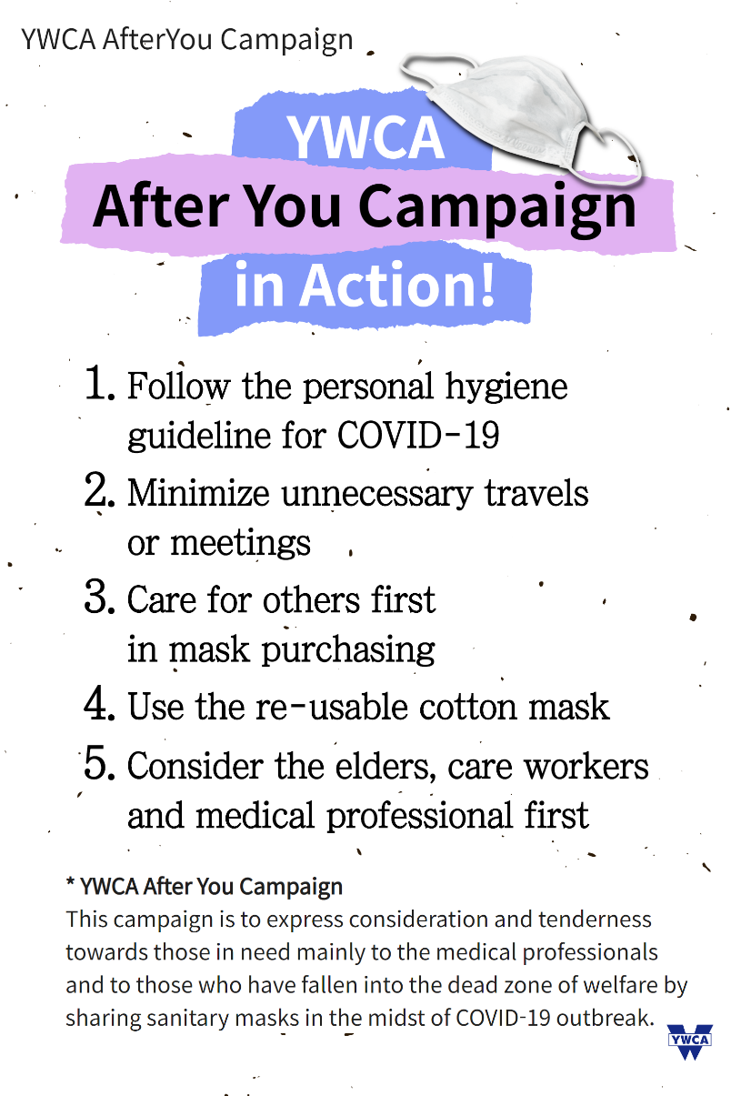

More than 7,800 COVID-19 infections have been confirmed throughout South Korea, killing more than 60. It is one of the largest outbreaks outside mainland China, where the deadly virus was first identified. This COVID-19 outbreak also has triggered panic buying of masks in South Korea which has become full-scale epidemic. The government has already centralized the distribution of masks in order to ban those who selfishly stockpile masks, stopped mask exports and allow mask production on weekends. Started on March 9th, according to the government plan, individuals can only be permitted to purchase two government-supplied masks per week. Furthermore, they will only be allowed to make purchases on dates that correspond to their year of birth.
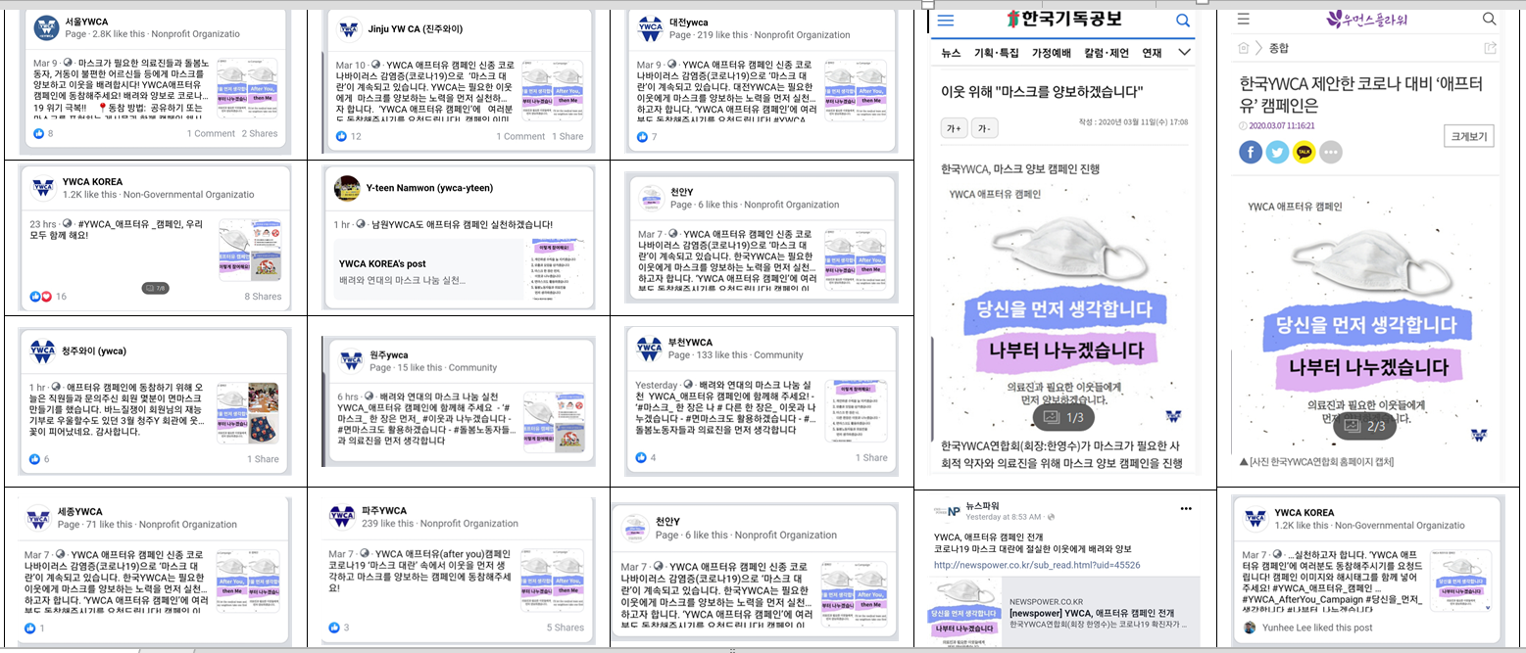
1 Korea YWCA and its local branches joining the online 'AfterYou' campaign. Several newspaper articles have been posted.
As the rising fear fuels the anthrophobia and xenophobia, the ‘YWCA After You Campaign’ aims to maintain love and tender heart and create the ‘togetherness’ among the YWCA members and the Korean society. Korea YWCA hope to set a good role model for the society and that this spontaneous outpouring of concern for fellow citizens and a willingness to shoulder hardships together will strengthen civic power and solidarity of the community.
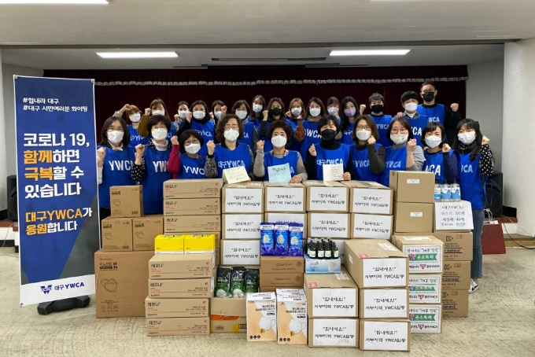 | 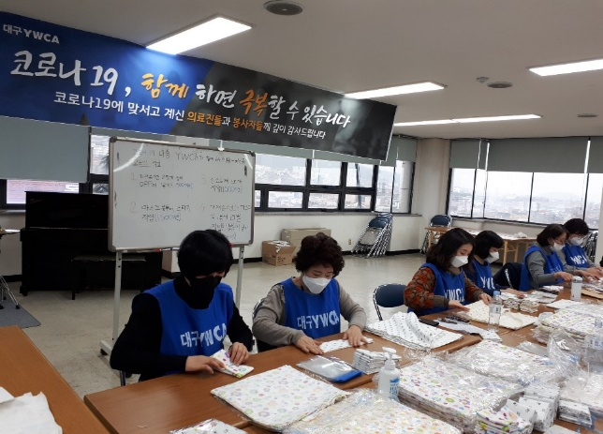
Daegu YWCA packaging the relief goods consist of vitamins, hand sanitizers and masks for its community.

Korea YWCA with the cooperation of the 40 other local YWCAs have donated the emergency relief fund and supplies such as hand sanitizers, disposable and reusable masks through Daegu YWCA to support the city of Daegu, the main battleground of the coronavirus outbreak in South Korea. Daegu YWCA has been playing the core role for its community by packaging the relief goods consist of vitamins, hand sanitizers and masks mainly to the medical professionals and to those who have fallen into the dead zone of welfare at the most critical moment of fighting the virus.

The ways to join the campaign is to upload the ‘YWCA After You Campaign’ poster on personal SNS and webpage with the hashtags #I_will_share_mine_first, #AfterYou_thenMe.
Simultaneously joined by all 53 local YWCA branches of Korea YWCA and its 100,000 members nationwide, the ‘YWCA After You Campaign’ hopes to deliver the message of love by ‘sharing mask for others’ and welcomes all the globally affiliated YWCA Member Associations to join us.

